**Purpose**

The purpose of this procedure is to show MSATPD Trainers how to use aXcelerate for their training and assessing.

**Scope**

This procedure covers all trainers at MSA Training and Professional Development using aXcelerate.

**Responsibilities**

It is the responsibility of the Data and Compliance Reporting Officer to providing training to new MSATPD prior to commencing their first training session.

It is the responsibility of the Data and Compliance Reporting Officer to ensure this procedure is current and changes in processes are reflected in a timely manner.

**Action**

**Welcome to aXcelerate**

Please use the below link to login into your trainer portal.

<https://app.axcelerate.com/auth/user/>

* You will receive an email prior to your training session asking you to set up your aXcelerate account and update your password.

Below is the dashboard you will see when you first log in.

Feel free to add or remove widgets, some useful widgets have already been added to assist you with task efficiency.

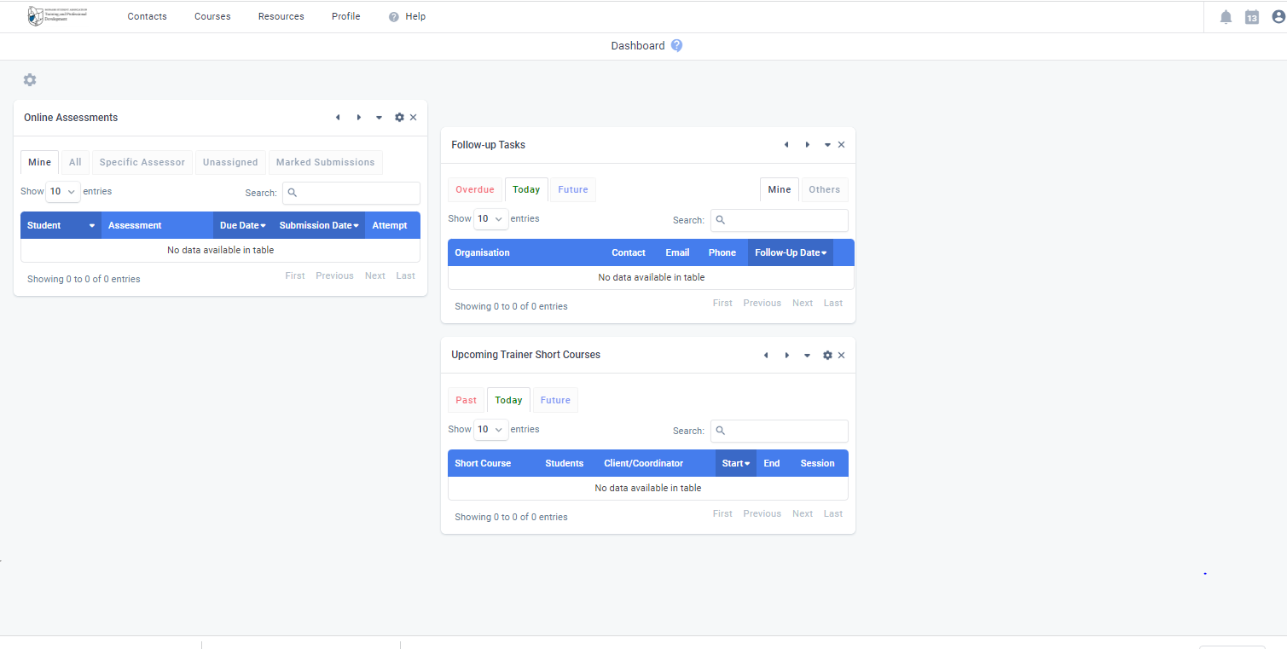

As a trainer you will be able to use aXcelerate to:

* Upload/Download Assessments
* Assess Online Assessments
* Mark Attendance
* Check student progress
* Email students
* Create announcements for the class.
* Check your calendar

**Marking Attendance.**

1. At the top of the page select “Courses” then “My Classes”.

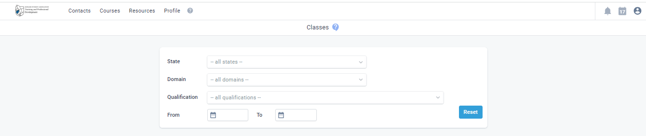

1. This will list your courses that have an active student. Select the course code you want to do attendance for.
2. This will take you to the course page. Select “Bulk Actions” on the top tab and select “Mark Attendance”.

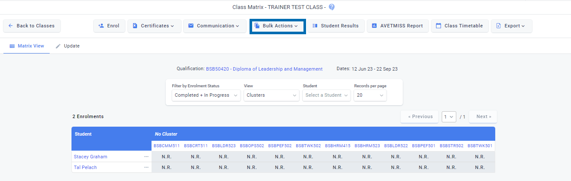

1. Select the Date of the class in the drop down. This will take you to the attendance for that session.
2. Select the sign button that’s at the top of the attendance and sign your signature against the attendance. (Always sign first before tick student’s attendance)
3. Select the tick or the cross depending if the student is present or absent on the day. Ensure the box is highlighted like the picture below.

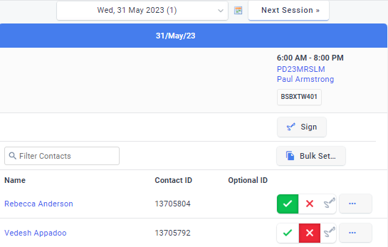

1. If you need to write any comments or change the time of student’s arrival/departure, this can be done by selecting the 3 dots against the student’s name.

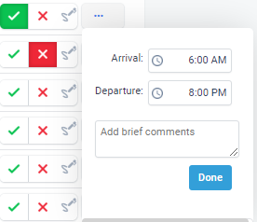

1. Once you have completed the attendance select “Save Changes”.
2. If you want an update on student attendance, go back to the class and select “Attendance Mode” under the view tab.

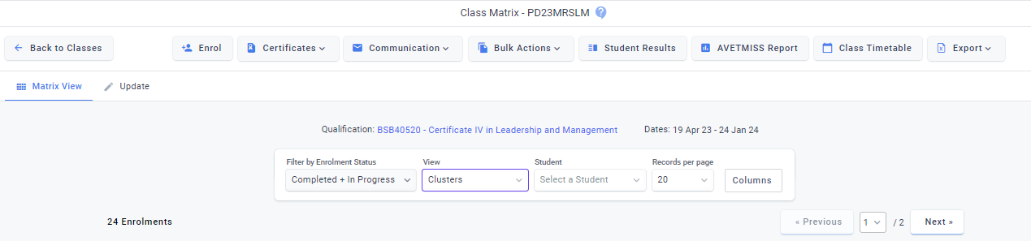

**Assessing Upload Download Assessments.**

If a Student has submitted anything it will come up on your dashboard under the widget “Online Assessments”.

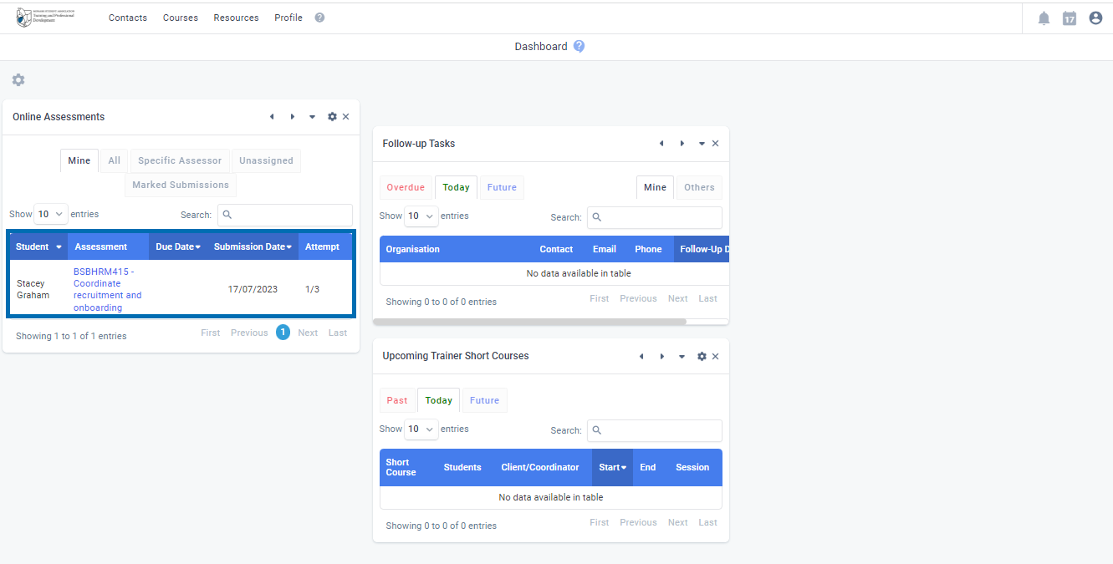

To assess assessments, you can either access these two ways. Either via the “Online Assessment” widget per student, or through the “Courses” tab at top of screen.

1. Go to “Bulk Actions” and select “Bulk Update Assessment Details”.

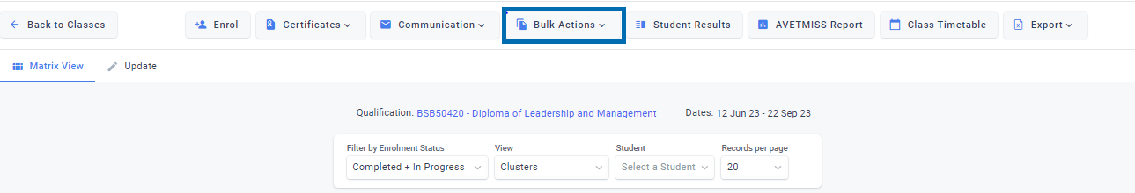

1. This will bring you to a new page that has a list of students and a list of assessments and reflections. The reflections will assess automatically, so no need to assess these.

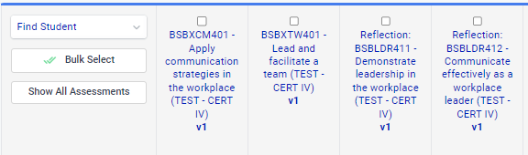

1. There will be 3 colour steps for each assessment.

* When it says “IP” (In Progress) and it’s yellow, this means the student has started uploading or commenced their assessment.
* When it says “IP” and it’s orange, this means the assessment has been submitted and is awaiting marking.
* When you assess the assessment, the color will turn Green and say S (Satisfactory) or Red for (Unsatisfactory).

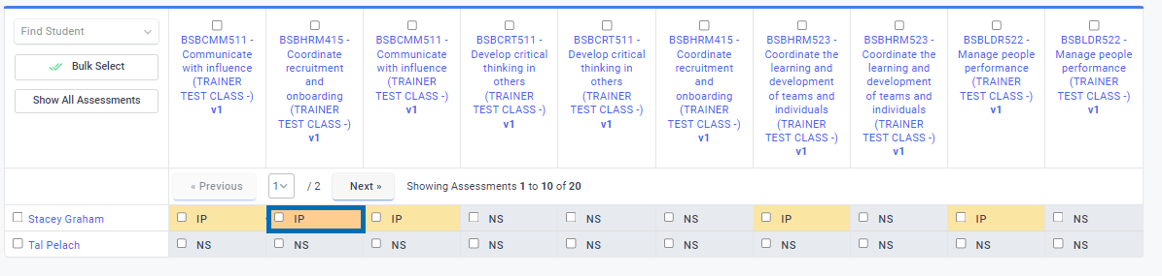

1. Select the orange one, or if there are multiple students you can tick each box. This will take you to an Assessment result page.
2. Select “Mark” at the top of the page.

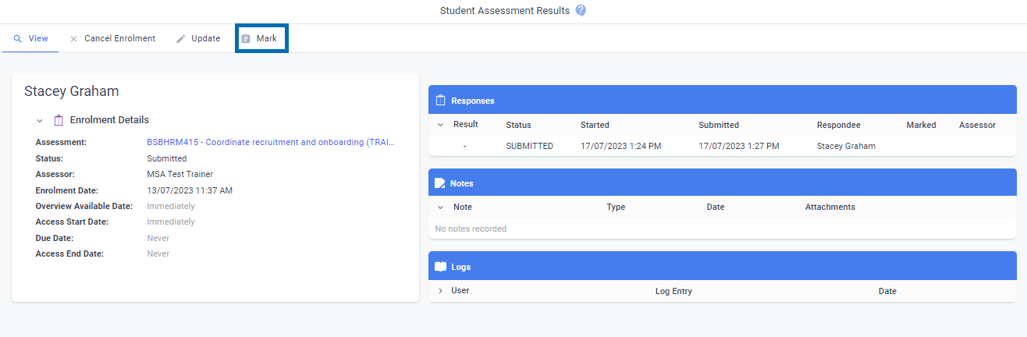

1. This takes you to the assessing page. You will need to download the assessment, assess and complete the feedback table on the assessment, then re-upload.

**Re-uploading assessment feedback**

1. Once you are ready to re-upload the assessment, select “Evidence”.
2. Then select “Browse Files”. Upload the assessed document.
3. If the assessment is Competent select “Satisfactory”. If the assessment is Not Yet Competent then select “Unsatisfactory”. If you select Unsatisfactory, it will re-open the unit for the student to re-submit the assessment again.

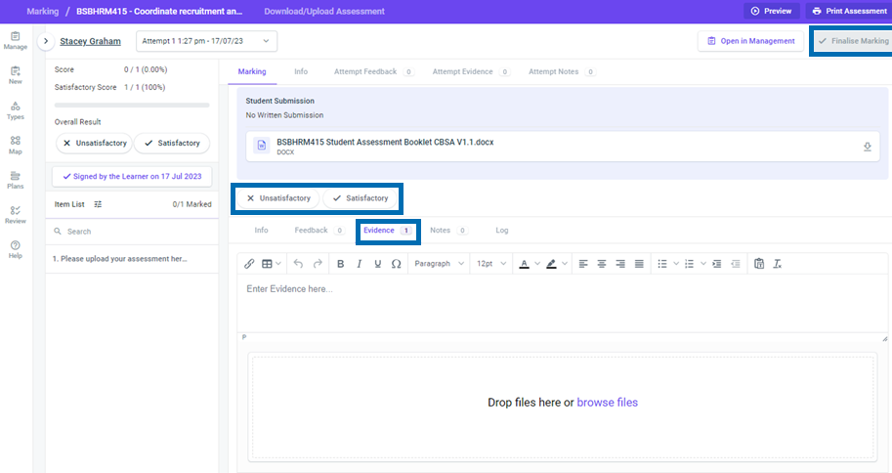

1. To ensure the assessment feedback is sent back to the student you must select Satisfactory/ Unsatisfactory and then select “Finalise Marking” in the top right-hand corner.
2. You will be required to sign a declaration every time you give feedback.

**Emailing Students:**

aXcelerate allows you to email students by the class or student. This can be used for sending extra documents or reminders about a session coming up.

1. Select the class you want to email by selecting Courses -> My Classes
2. Select the “Communication” tab on the class bar.

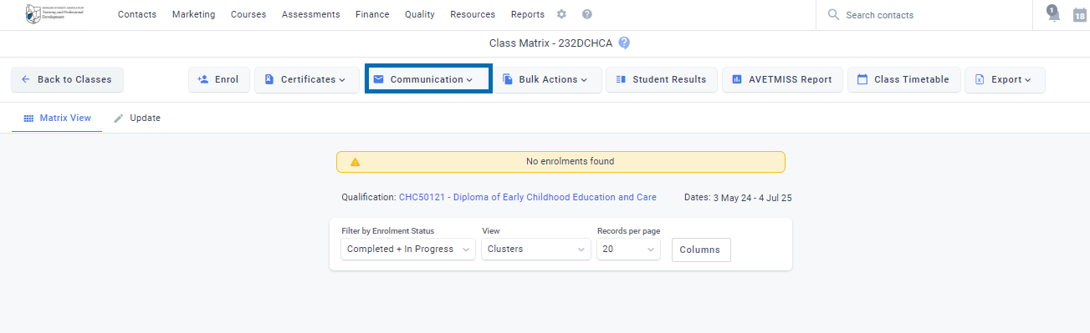

1. Select Plain text.
2. Select the Salutation (When you select this it will auto fill the students name if you are sending in bulk).
3. Update the subject.
4. Select your email when sending an email. This will allow the students to reply to you if they need to.
5. Message: Write your message.
   1. Emails and messages to students must only be related to the current course they are enrolled into. You must not promote external business or share personal information about other learners as outlined in the consultancy agreement.
   2. Ensure you treat all students and staff with respect.
6. Select your signature, it will auto fill this for you.
7. Attach File: If required.
8. Before you send your email, ensure you check the right-hand side for the list of students. (Please Note: Withdrawn students do still come up so ensure you remove them when sending an email).
9. Send Email.

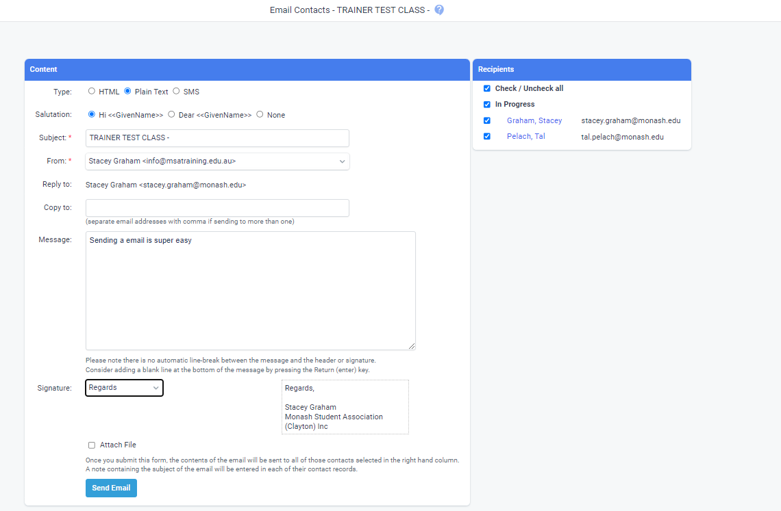

**Creating Announcements.**

You will now be able to create announcements on aXcelerate that will show up on the student’s main page in their portal. This function can be used to remind students to bring something to class, or sign documents before uploading, remind them of a due date etc.

To do this is similar to the email.

1. Select the class you want to email. By Courses -> My Classes
2. Select the “Communication” tab, then select “Announcements”.
3. Select “Add Announcement”.

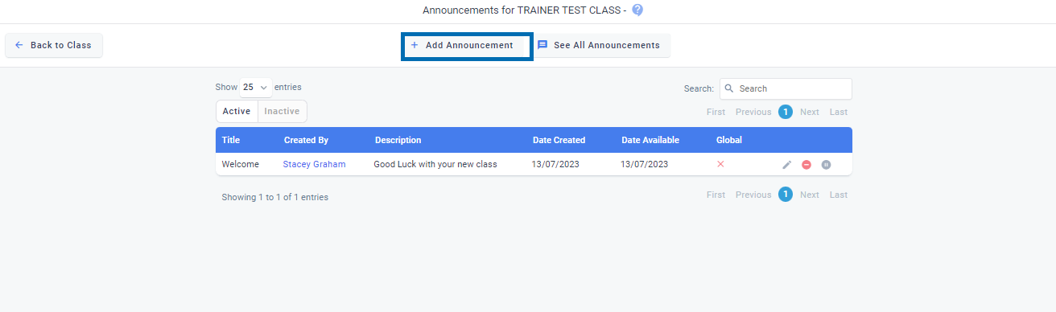

1. Create your announcement by adding a title.
2. Insert a description.
3. Set the time you want the announcement to appear.
4. Create Announcement.

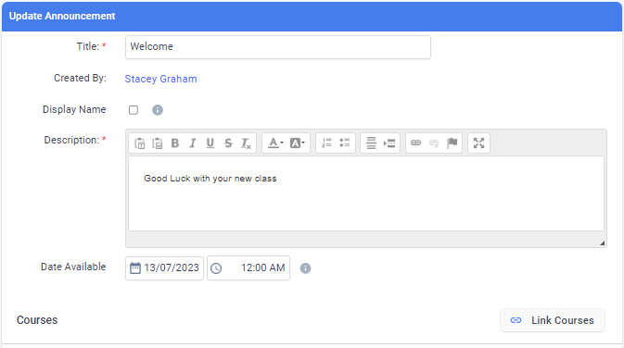

**Review date**

1 July 2025