**Advice for Trainers completing ASS Task 3 & 6**

* From Chemène Sinson

This requirement is to meet the **Assessment Conditions** for [TAEASS413 Participate in Assessment Validation](https://training.gov.au/Training/Details/TAEASS413/unitdetails).  Here's a screenshot of the relevant content:

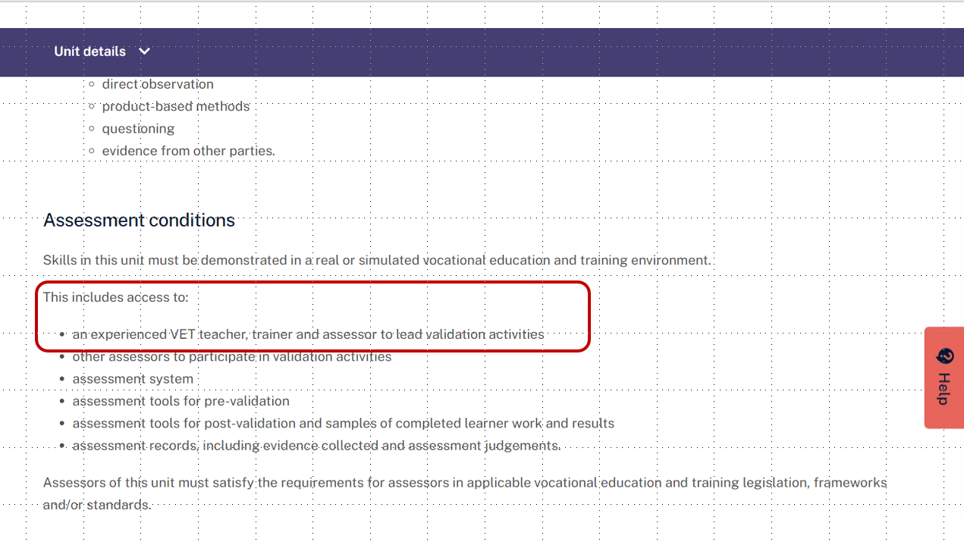

**Next comes the question of how to interpret 'leading'**

I discussed this at length with the auditor who supported me with the development of the TAE assessment tools, and she recommended that the TAE trainer (or equivalent) was the most logical choice of person to lead each validation, but to manage workload, I think there could be creative ways for the TAE trainer to lead more than one validation group at a time.

For example, this is what I've done using Zoom:

1. (ahead of time) brief the TAE participants on the purpose of the validation, their roles.  Give them the materials needed for the validation and answer preliminary questions
2. Give some time for TAE participants to prepare for the validation and ask questions as needed, beforehand.
3. Conduct a live online validation meeting - this works when I have about 12 participants. Much more than this gets tricky, and I find that for the first validation I typically need about 2 hours.  In this meeting, I:
   * first, confirm everyone's understanding of the validation purpose and peoples' roles
   * next, send participants into breakout rooms to discuss in groups of 3 or 4 (I usually tell each person that they must each complete their own copy of the validation record for assessment purposes, but you could argue that a deputy leader could be responsible for completing it on behalf of the group - you'd just need to make sure everyone actively contributes, and I find asking each person complete their own record is a good way to do this, but that's a personal choice)
   * then, I rotate between groups to observe participant engagement and contributions, and can offer further advice and support when needed.

So, I don't think you could name a TAE participant as the validation leader - it needs to be an experienced person, like the TAE trainer or equivalent - but you could use creative ways to ensure that the poor trainer doesn't need to lead one validation team at a time (here I am assuming that validation teams’ number about 3 or 4 people, to ensure that everyone participates).

It is still a big workload for the TAE trainer, though, to lead 6 validations for each student!